Class examples
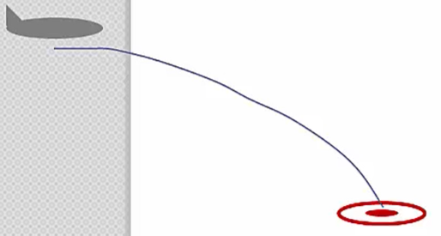
- A bomber is travelling horizontally at 300m/s at an altitude of 2.5 km towards its designated ground target. How far ahead should the target be when the bomb is dropped to hit the target?

- A soccer player kicks the ball with an initial velocity of 18.0 m/s at 35º above the horizontal.
- Calculate the time the ball is in the air.
- How far away will the ball land from the player’s position?
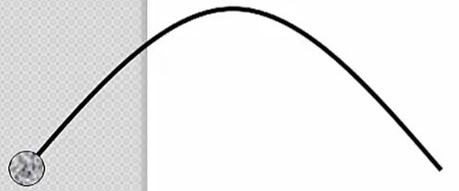

- During a tennis match, a player serves the ball by smacking it towards the opponent’s half. When the racquet makes contact with the ball it is 2.3 m above the ground, and it is initially hit at a speed of 70 km/h 10.0 º above the horizontal. The ball only just sails over the net which was 18.0 m away from the serving player. How high is the top of the net above the ground?

